USER MANUAL

Study Management Web application

Build using ASP.Net Web app

By Student: 20109284 Witbooi

The Student Management web app has been published on azure and can be accessed on any local machine or mobile app with internet connection.

Link for the web app: <https://studymanagementprj.azurewebsites.net/> .

The web application has been built for mostly desktops but with azure you can also use the application on your mobile application. But in this manual the desktop version will used and explained.

When you enter the link above it will redirect you to the web app hosted on azure website.

Home page has a minimalistic design shown below:

Graphical user interface, application

Description generated with very high confidenceAs you can see on the navigation bar on the title and the login and register buttons appear.

Since we are demonstrating how to use this website. Let’s Register by clicking on the register button.

This register page show below allows to the user to enter in their desired user name, email address, password and confirm password to make sure your password match. Which also makes you remember the password you entered first.

Graphical user interface, application

Description generated with very high confidence

Validations

The web app is equipped with validations to ensure the proper values and data are entered and stored as shown below:

Table

Description generated with high confidenceAs you can see we have entered only the fields for the user name and email address and click on submit which will show an error and what it is we did wrong.

A picture containing graphical user interface

Description generated with very high confidence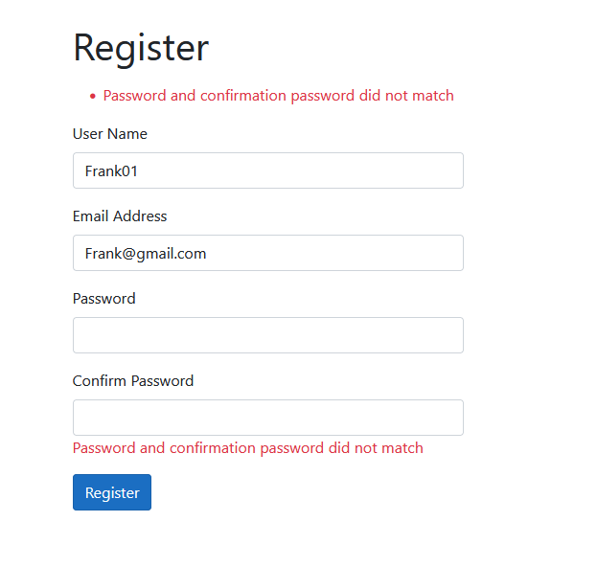Now then what if we also enter the correct form for the password field. But we miss a letter or two here and there. The web app will tell you that the passwords don’t match. As shown below:

Once we enter the correct details we will be automatically logged in.

When logged in the User interface (Home Page) has new links in the navigation bar.

The home, module, view, and graph links only show after the user has logged in. As shown below in figure 1 Home page logged in. When you press on the home page link nothing will change as you are already on the home page.Graphical user interface, application, Teams

Description generated with very high confidenceWhen you press on the Module link the page will consist of a title Module Information and labels and fields to enter the Module Code, Module Name, Module Credits the Class hours per week for a module, the start date of the module, the semester week as well as the date learner started studying and the hours they worked on a module. The Module Page is also equipped with validations if the incorrect information entered.

Figure 1 Home Page Logged in

You can see in figure 3 Module Info Validations what happens when we click on the save button without entering any values in any of the fields.

Graphical user interface, application

Description generated with very high confidenceGraphical user interface, application

Description generated with very high confidence

Figure 2Module Info

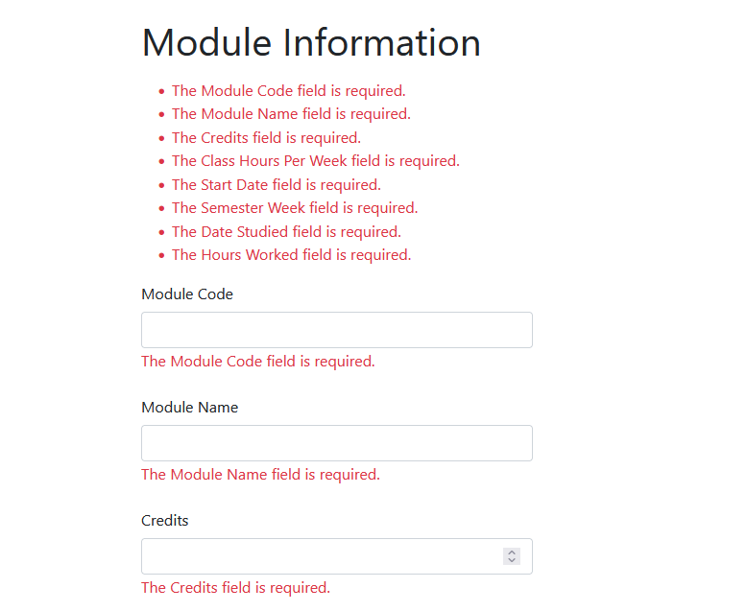

Figure 3 Module Info Validations

After adding the necessary details for your module click on the save button which will redirect you to the view page. For this manual I have entered the first few modules to populate the table. Each row can be edited by pressing the edit button or deleted by pressing the deleted button. As you can see on figure 4 View page with data. The layout has title module list on the left with a create module button on the right. Which when clicked will redirect you the module page.

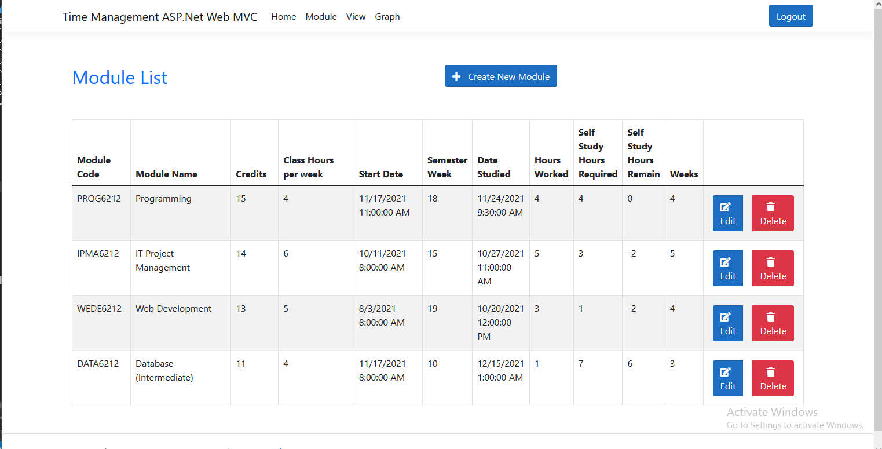

Figure 4 View page with data

We will now click on the edit button the first row. The edit button when clicked will redirect you the Edit Module page. As shown in figure 5 Edit Module Page below. The Edit Module Page consists of a Label for the Module Code and Module which can be edited. We changed PROG6212 to HCIN6212 as well as the Module Name for it to Human Computed Interaction. We click on update to make the change to the Module. If you decide you don’t want to edit the module press on the back button and you will be redirected to the view page.

Graphical user interface, text, application

Description generated with very high confidence

Figure 5 Edit Module Page

Figure 6 shows the row has been updated to Module Code has been changed to HCIN instead of PROG6212 and Module Name.

Graphical user interface, text, application, email

Description generated with very high confidence

Figure 6 Edited row

Now let’s try an delete a record by pressing on the delete button next to the edit button with the color red. Lets try and delete the record for the web development module. As you can see below in figure 7 Delete Module you receive a prompt when deleting a module to ensure you really want to delete a module. Click on *OK* to delete the module and *Cancel* will leave things as is on the view page.

Graphical user interface, application

Description generated with high confidence

Figure 7 Delete Module

As you can see now in the figure 8 Record Delete below the web development record has been deleted you can see the change when comparing the figure 4 View page data

Table

Description generated with high confidence

Figure 8 Record Delete

Now we continue to the graph page by click the Graph link in the navigation bar. In Figure The Graph View will you the hours spent on each module.

Chart, bar chart

Description generated with very high confidence

Figure 9 Graph View

This is also how the view page looks with any records without any records.

Graphical user interface, text, application

Description generated with high confidence

Figure 10 View without records